**Software Requirements Specification**

**for**

BookIt

**Version 1.0 approved**

**Prepared by**

**GROUP 2**

**January 25, 2019 -**

**Table of Contents**

**Table of Contents ii**

**Revision History ii**

**1. Introduction 1**

1.1 Purpose 1

1.2 Document Conventions 1

1.3 Intended Audience and Reading Suggestions 1

1.4 Product Scope 1

1.5 References 1

**2. Overall Description 2**

2.1 Product Perspective 2

2.2 Product Functions 2

2.3 User Classes and Characteristics 2

2.4 Operating Environment 2

2.5 Design and Implementation Constraints 2

2.6 User Documentation 2

2.7 Assumptions and Dependencies 3

**3. External Interface Requirements 3**

3.1 User Interfaces 3

3.2 Hardware Interfaces 3

3.3 Software Interfaces 3

3.4 Communications Interfaces 3

**4. System Features 4**

4.1 Class Search 4

4.2 Class Subscription 4

4.3 Comment and Rate Classes 4

4.4 Book Search 4

4.5 Book Post 4

4.6 Private Messaging System 4

**5. Other Nonfunctional Requirements 4**

5.1 Performance Requirements 4

5.2 Safety Requirements 5

5.3 Security Requirements 5

5.4 Software Quality Attributes 5

5.5 Business Rules 5

**6. Other Requirements 5**

**Appendix A: Glossary 5**

**Appendix B: Analysis Models 5**

**Appendix C: To Be Determined List 6**

**Revision History**

|  |  |  |  |
| --- | --- | --- | --- |
| **Name** | **Date** | **Reason For Changes** | **Version** |
| M.J.J | 2/11/2019 | Filled in assigned areas | 1.0 |
| M.J.J | 2/18/2019 | filled in section 2 | 1.1 |

# **Introduction**

## **Purpose**

The purpose of this project is to create a website that allows users to view a list of class availability, while providing a web user interface that allows for smooth transactions for students to sell and buy books for their courses.

## **Document Conventions**

Mobile website that allows users to track courses and post/purchase books. User account that allows tracking courses, finding available books for upcoming course and posting books for sale. User selected option for course notifications based on predefined criteria. Course rating system. Allows user to post reviews and rate their class experience. It is important to note that we are not responsible if a student purchase the incorrect book, it is important that they make sure they are purchasing the correct textbook.

## **Intended Audience and Reading Suggestions**

There will be different type of reader that the document is intended for, such as developers, project managers, client, and documentation writers.

...To be continued

Describe what the rest of this SRS contains and how it is organized. Suggest a sequence for reading the document, beginning with the overview sections and proceeding through the sections that are most pertinent to each reader type.

## **Product Scope**

We will be creating a front end to build a functional user interface that will be beneficial for students to buy and sell their books to other students. The back end will provide the students information and prices of the book. The biggest benefit that it will allow users to make a small profit, along with getting feedback about the book and/or the class.

## **References**

None right now

# **Overall Description**

## **Product Perspective**

## This site will be the first iteration of its design. The idea of the site was to create a easy to use website that allows the user to view classes that are available to register for. The site will also allow for easy peer-to-peer transactions. In order to do this the site will be connected to a database server that stores the information related to books for users. The site will use web scraping to populate a list for users. **Product Functions**

* *allow the user to login in and out of website*
* *allow the user create a account*
* *allow user to view list of classes*
* *user can view list of books related to classes*
* *user can leave reviews for classes*
* *user can leave reviews for books*
* *user can contact other users to set up transactions for books*
* *site is modular*
* *site connects stores information on server*

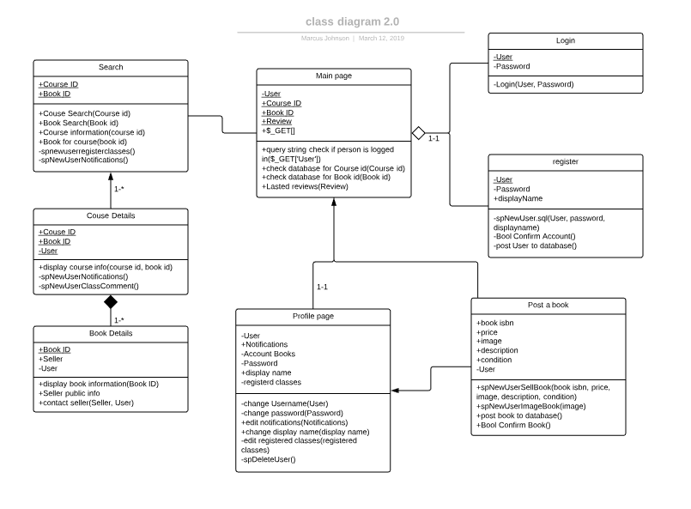

*Figure 2.2.2 Class Diagram: Overview*

## **User Classes and Characteristics**

User class 1: Customer

Will be able to log into or register for website and create a profile. Task will include managing profile information, looking up available classes and transactions with other users to purchase books. requirements of the customer will extremely basic but they will need to have access to a kent state university student account. customers will only have the ability to change their own profile information.

task

* login/create profile
* view list of available classes
* purchase books
* edit profile information
* rate classes/books
* reply to seller

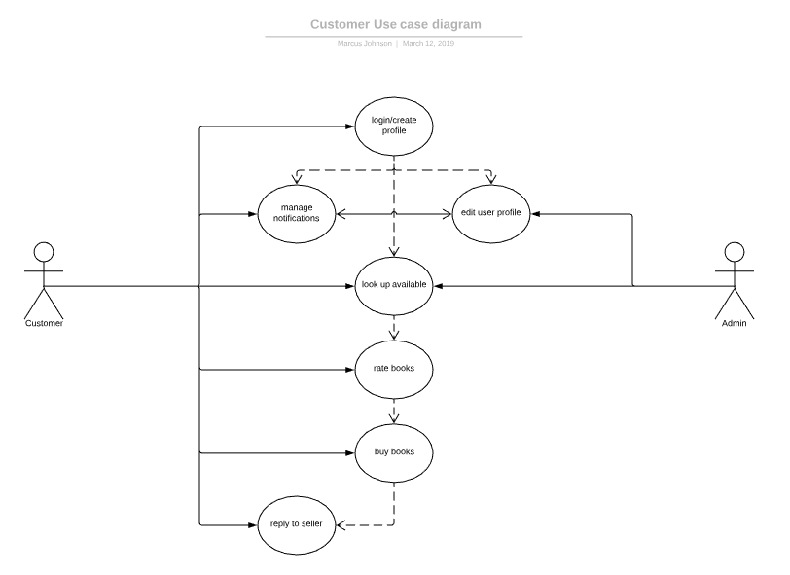

*Figure 2.3.1 Use Case Diagram:Customer*

Will be able to log into or register for website and create profile. task will include managing profile information, inventory of books available for purchase, setting up transactions with customers, looking up classes to assign a book to. will need access to kent state university student account. will also need basic information on the book and what class it might relate to.

task

* login/create profile
* view list of available classes
* add/remove books to inventory
* edit profile information
* rate books/classes
* contact buyer
* set up transactions with customers for book purchase.

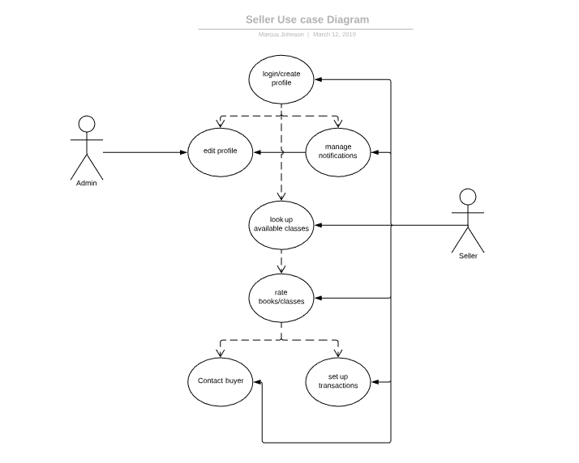

*Figure 2.3.2 Use Case Diagram: Seller*

## **Operating Environment**

The software will operate on an Ubuntu server 16.04 LTS virtual machine with a single VCPU, 1GB of RAM, and a 64GB SSD. Additionally, the software requires Apache 2.4.18 web server, MySQL 14.14 database, PHP 7.3.1, and a working internet connection.

## **Design and Implementation Constraints**

For this website a basic server will required along with an intimate knowledge of html and php. Web scraping will be used to pull information from the kent state university website this will be done by a independent program and knowledge of this process will be required. For security means a standard user name and password will be required. A display name will be available for all users to create also to ensure personal emails are protected for rating classes or books. messaging for transactions is be done via email only after both parties have agreed to the transaction. Sellers without a kent state university student account should require approval from a site admin in order to post books in order to improve transactions between customers.

## **User Documentation**

*N/A*

## **Assumptions and Dependencies**

The only Third-party Component that may be needed for this site is a web server that is hosted by one which would be needed in the event that the company decides to not build their own server. Outsourcing of a application that provides the information from the web scraping could also be an option if inhouse developers are unable to create one.

# **External Interface Requirements**

## **User Interfaces**

The product UI is a website built using Bootstrap 4.3.1 and Javascript/jQuery. The main pages include the home/search (to search for books or courses), search results, user, and course/book data pages.

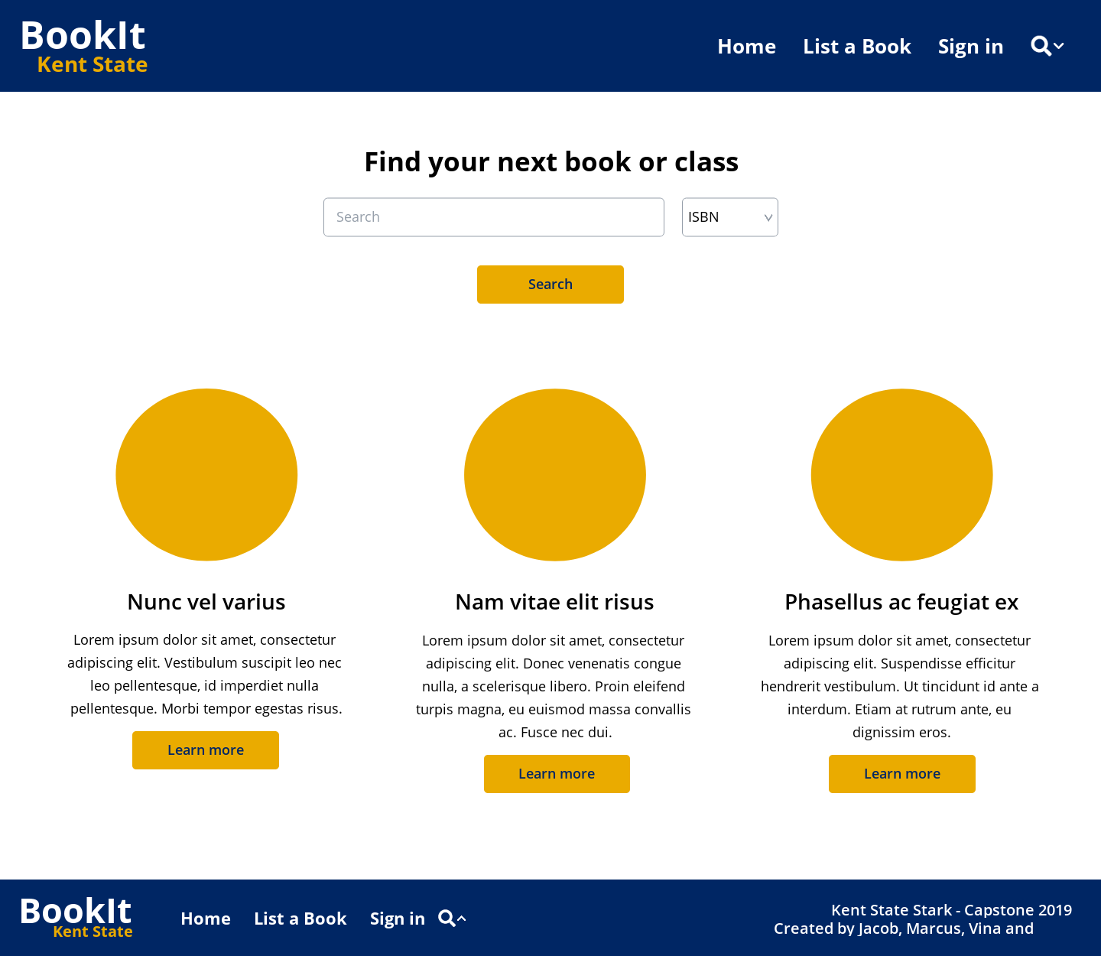

*Figure 3.1.1 Mockup: home page*

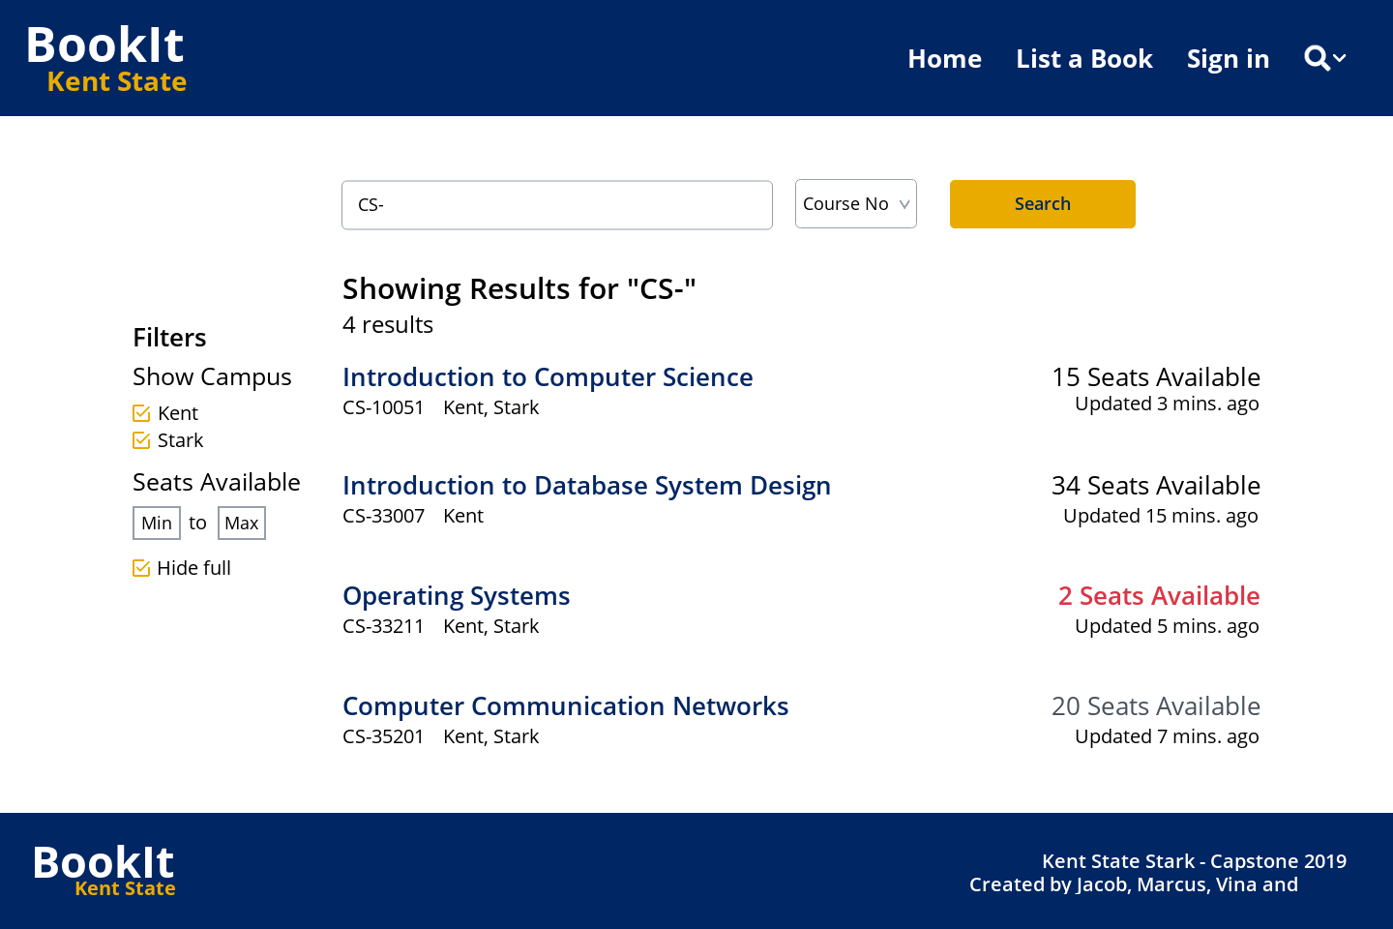

*Figure 3.1.2 Mockup: Search results*

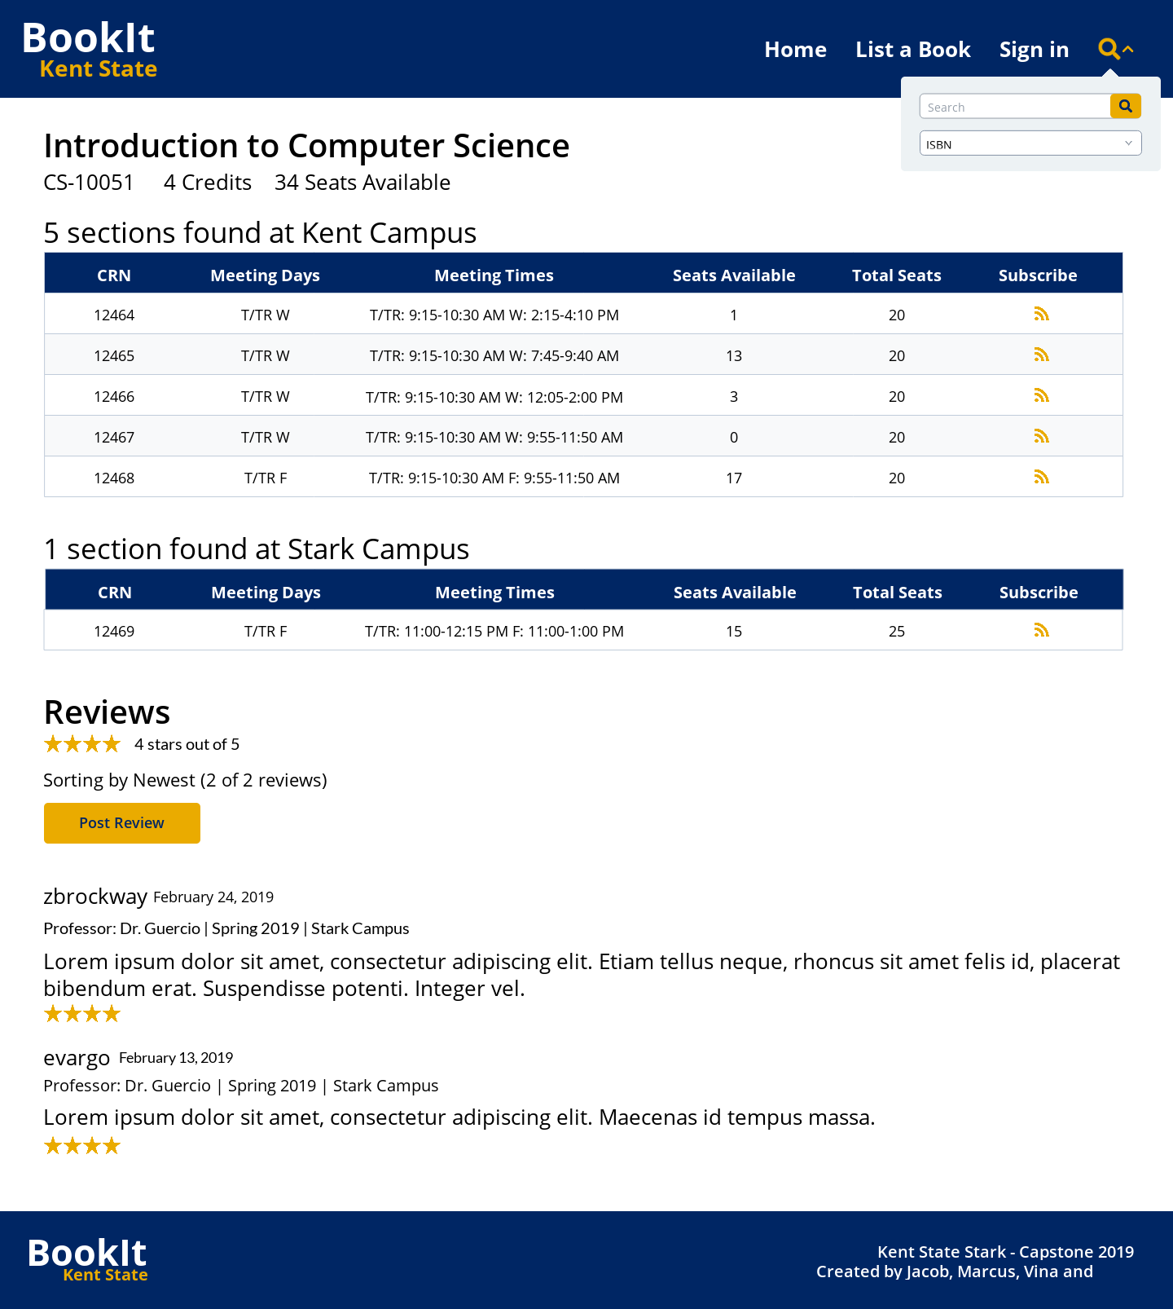

*Figure 3.1.3 Mockup: Course Lookup*

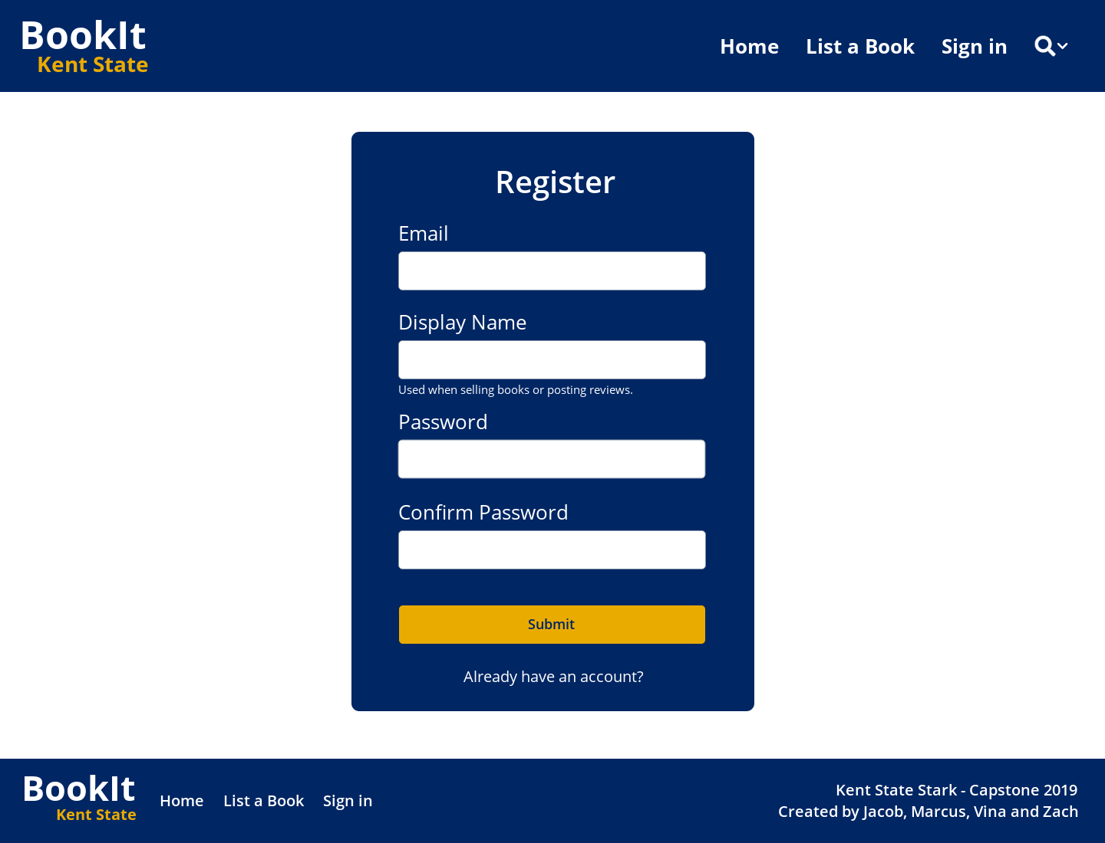

*Figure 3.1.4 Mockup: Registration*

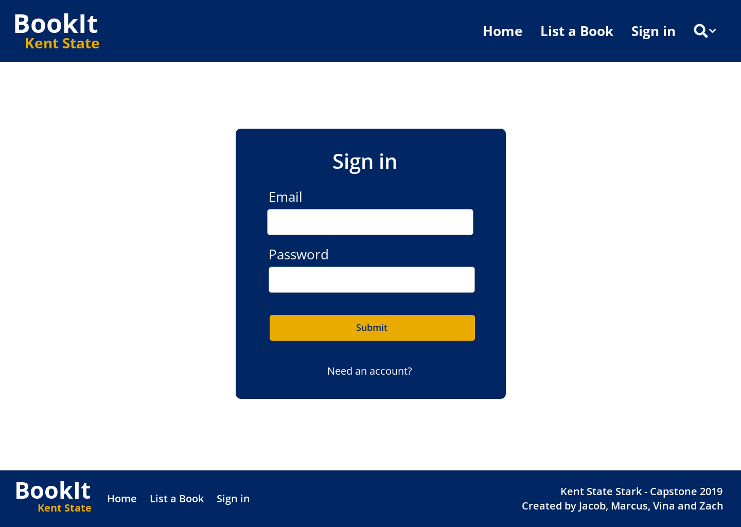

*Figure 3.1.5 Mockup: Sign in*

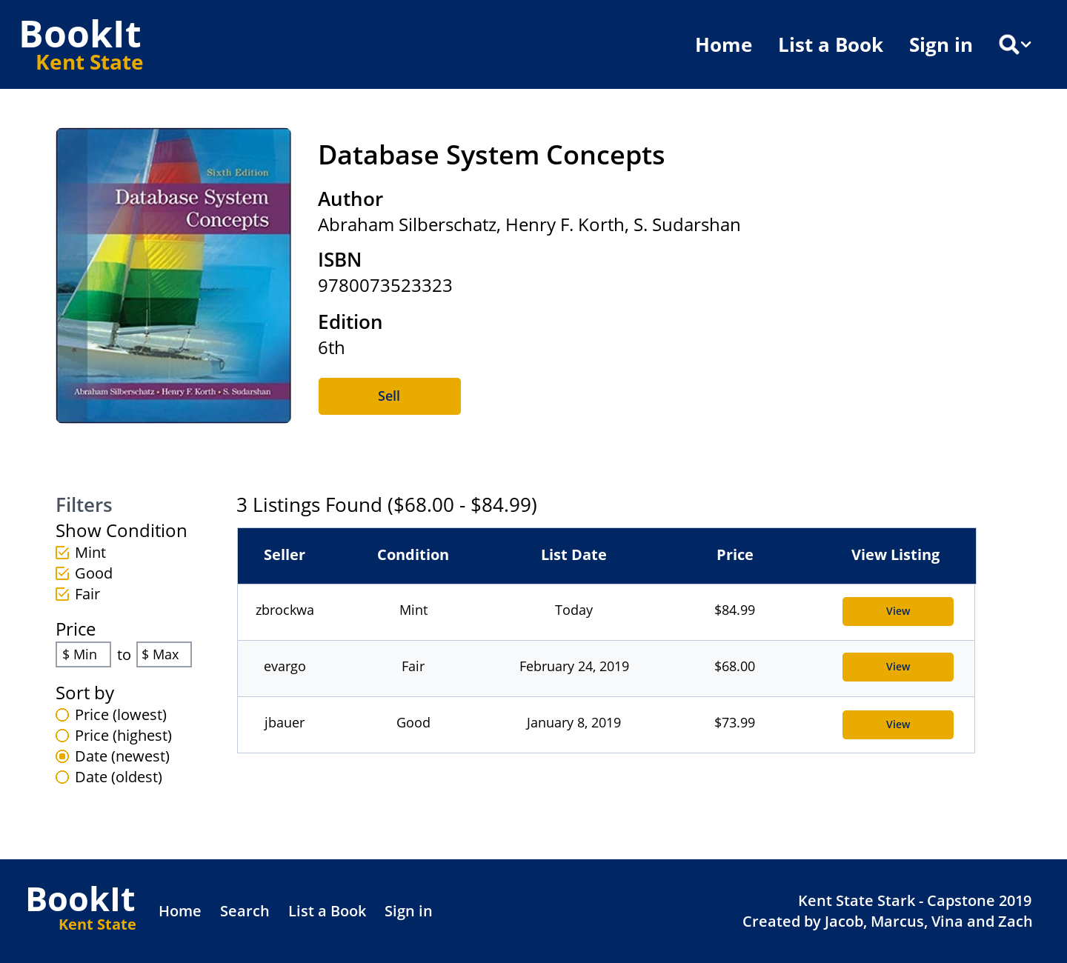

*Figure 3.1.6 Mockup: All active listings for an individual books*

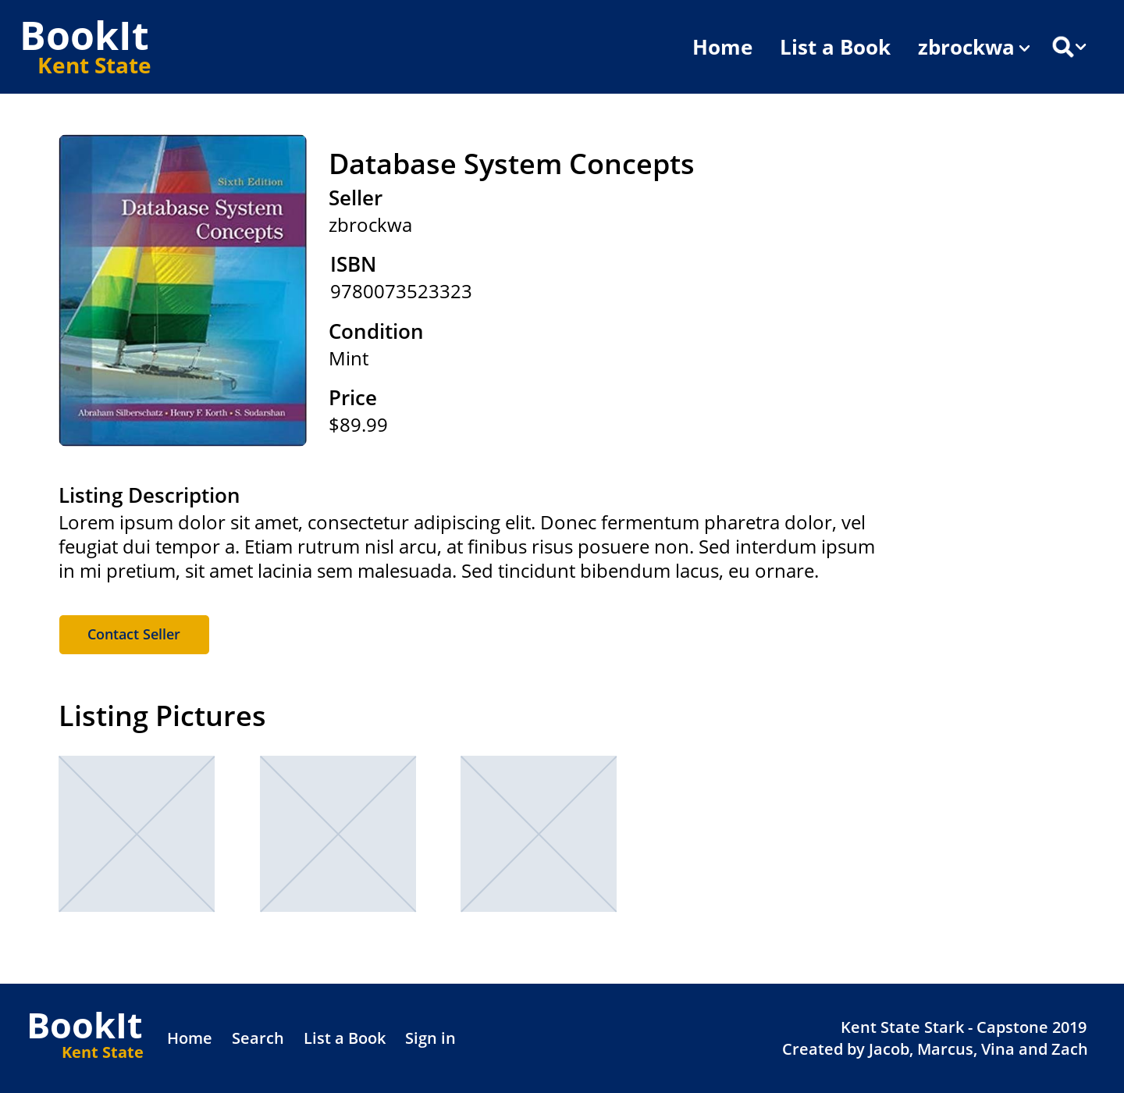

*Figure 3.1.7 Mockup: Individual book listing*

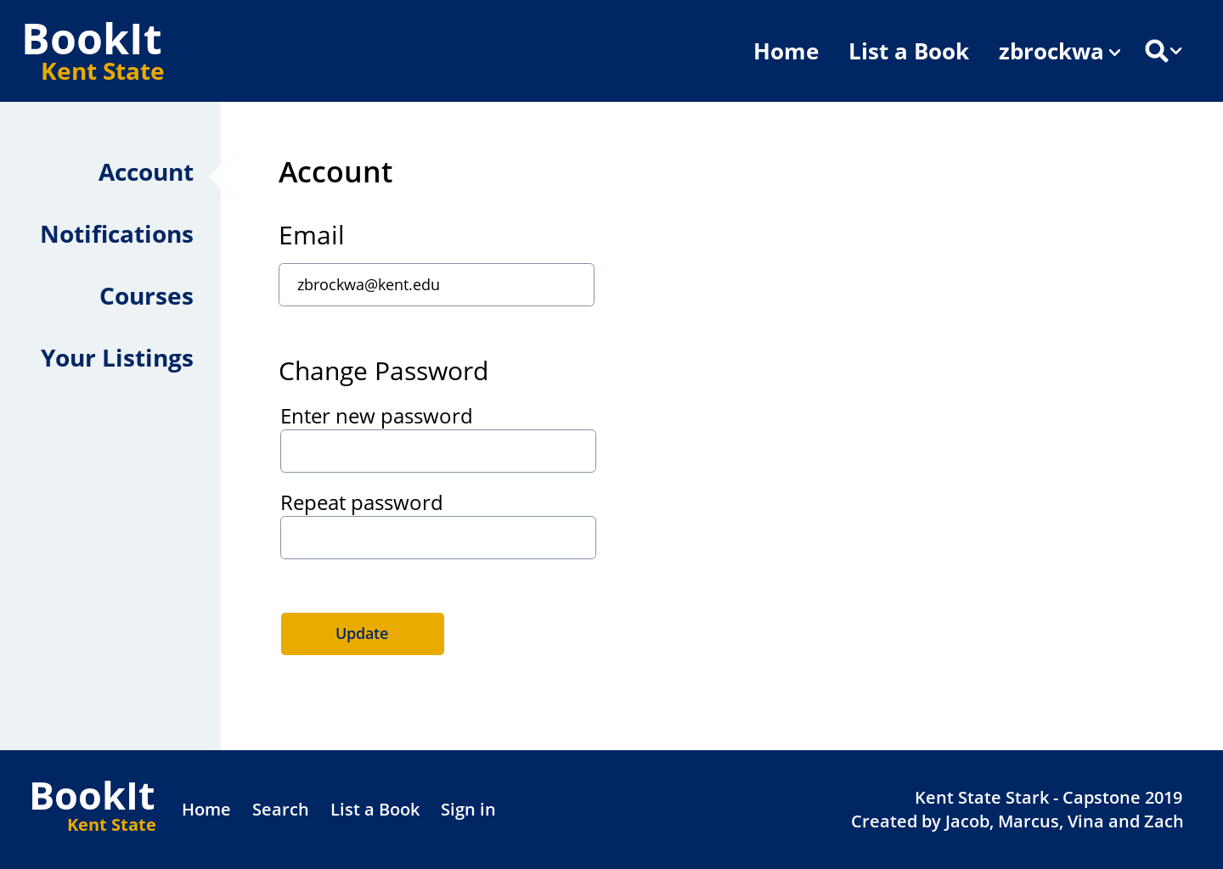

*Figure 3.1.8 Mockup: Account main page*

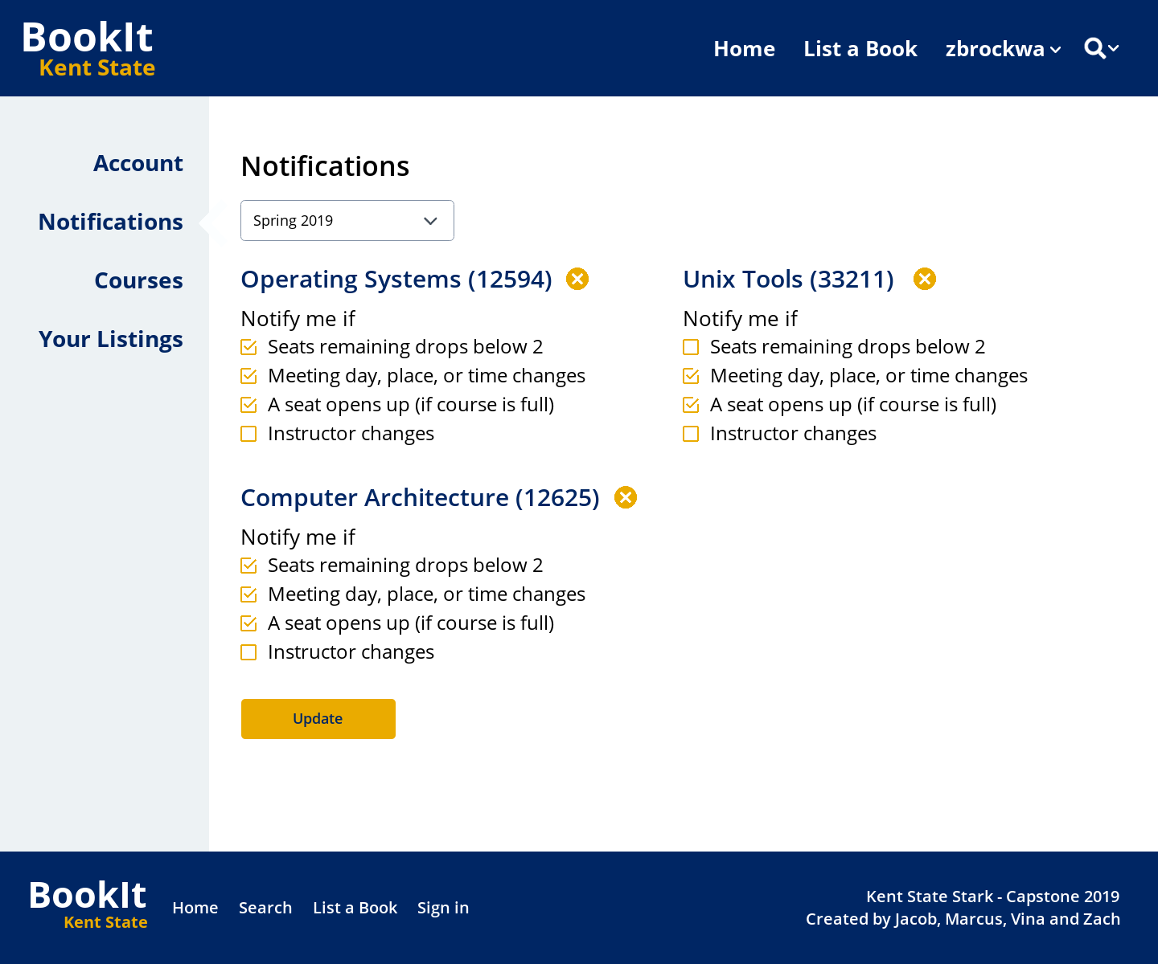

*Figure 3.1.9 Mockup: Course notifications*

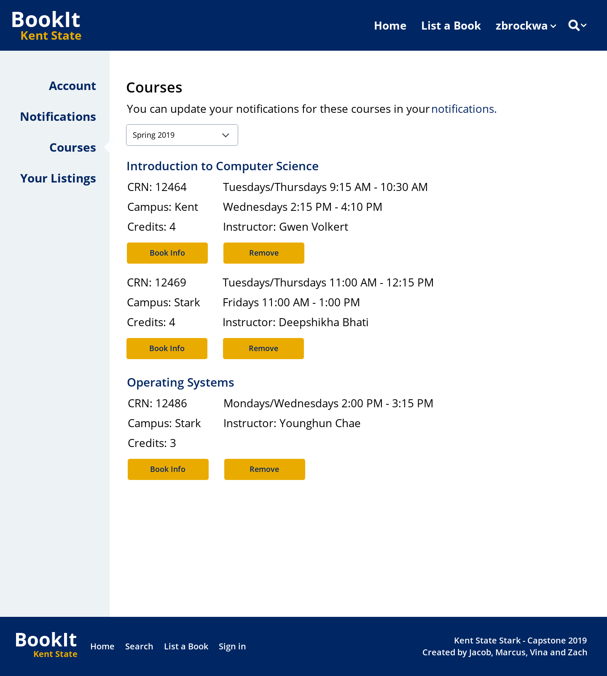

*Figure 3.1.10 Mockup: Subscribed course info*

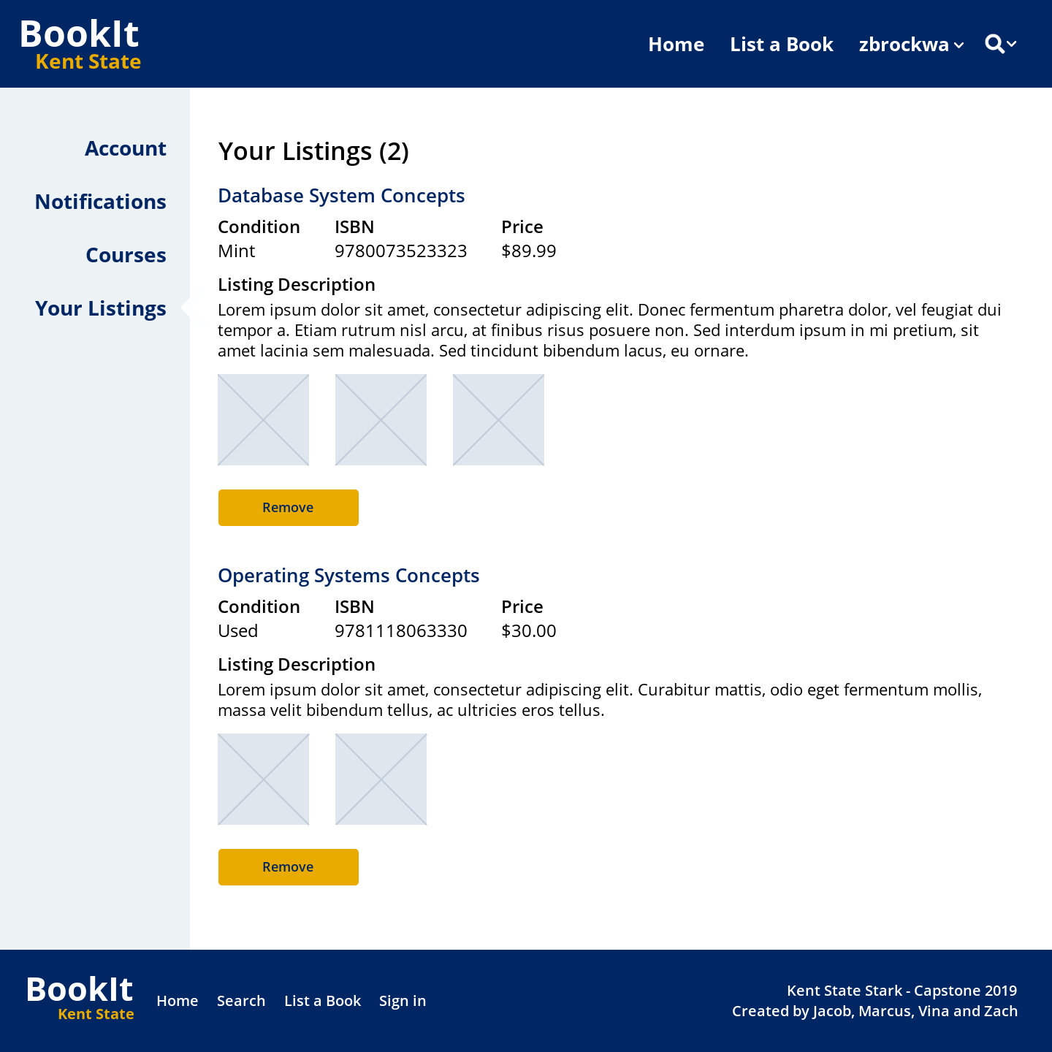

*Figure 3.1.11 Mockup: Active book listings for an individual user*

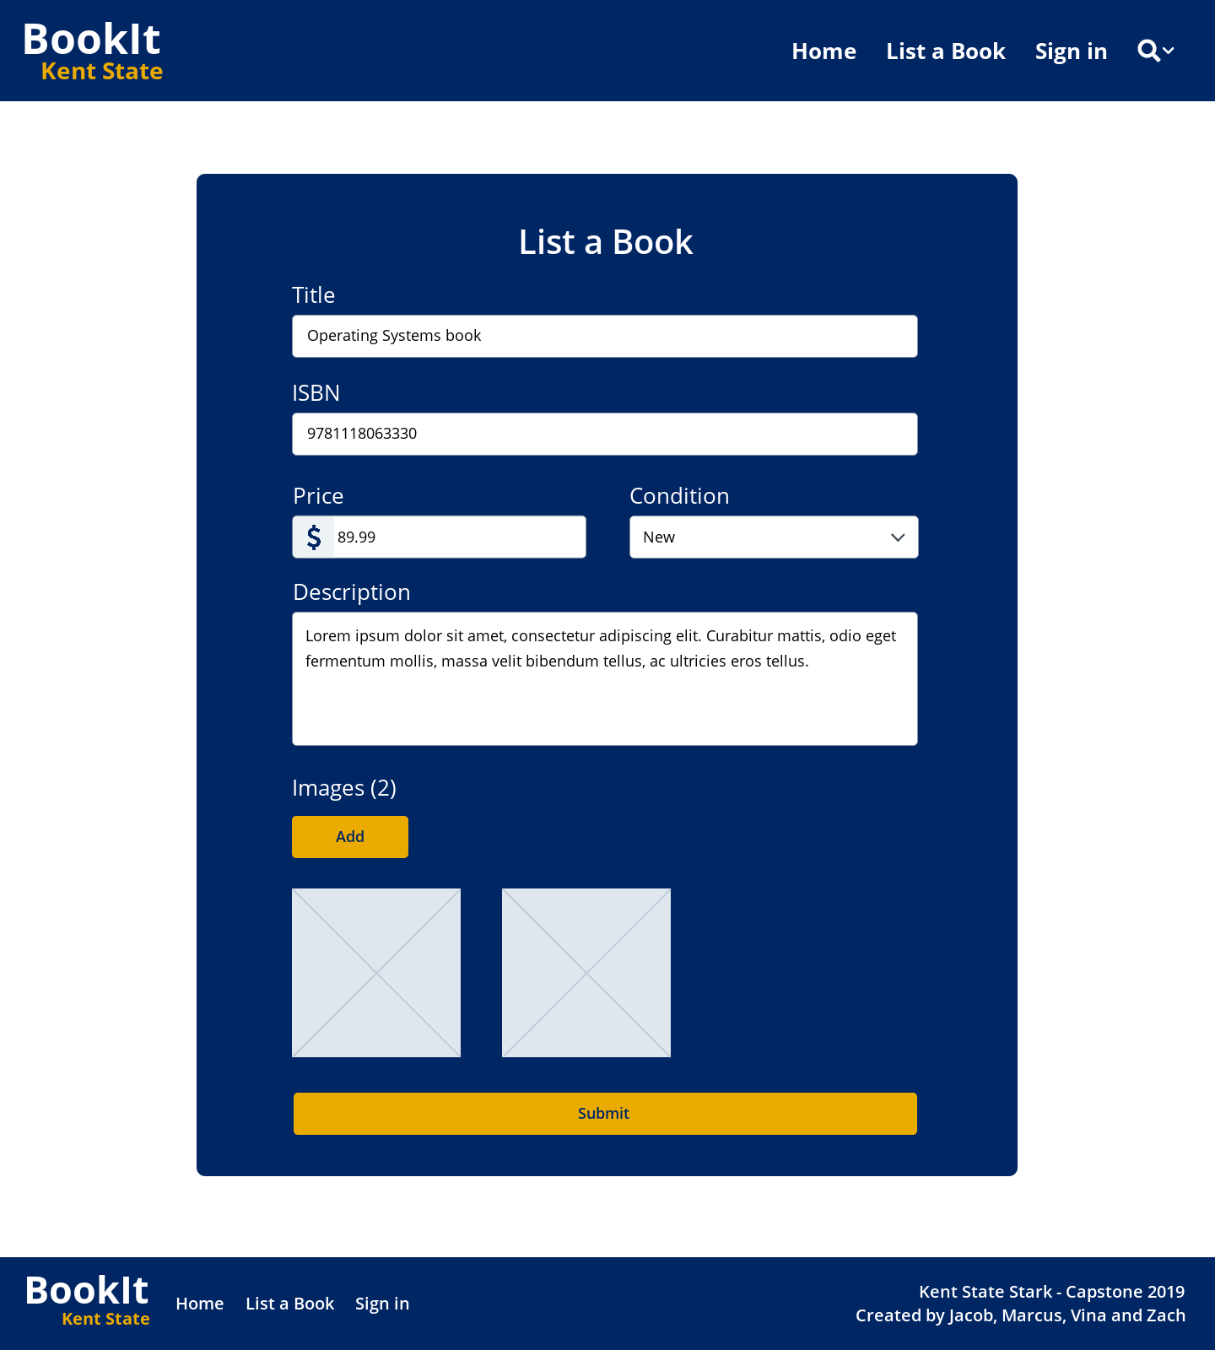

*Figure 3.1.12 Mockup: List a new book*

## **Hardware Interfaces**

The product is accessible on any device with a working internet connection and modern web browser. Additionally, a keyboard will be required to search for specific courses and books through the product UI.

## **Software Interfaces**

There are 3 main interfaces to the product: the database, web front end, and jobs interfaces. The MySQL 14.14 database interface is responsible for persistence of data collected from the jobs and web front end interfaces. The web front end displays data from the database and provides a way for users to interact with it. The jobs interface will be a set of small Python scripts to be run regularly to (1) access and insert data into the database interface from the Kent State course registration website and (2) send out batch emails of user notifications (requested by the users).

## **Communications Interfaces**

To obtain the most up-to-date data about courses, the product accesses Kent State's website. This connection occurs through HTTP, and will gather data mainly on the current amount of slots available to be registered for. All data will then be saved in the product's database. To notify users of activity in their subscribed courses, the product will send emails to user email addresses via SMTP port 465.

# **System Features**

## Search for classes that will be available in the next semester

4.1.1 Description and Priority

This feature will allow users to browse through a list of classes and see more detailed information about each class. This is a high priority feature

4.1.2 Stimulus/Response Sequences

Stimulus: User requests to browse a list of classes filtered by selected criteria

Response: System provides the user with a list of classes filtered by selected criteria

Stimulus: User requests to see more detail about a course

Response: System provides all information about selected course

4.1.3 Functional Requirements

Feature Requirements: Class Search (REQ-CS)

|  |  |  |
| --- | --- | --- |
| Feature ID | Feature Name | Description |
| REQ-CS1 | View Courses | The application will display a list of classes |
| REQ-CS2 | Filter Courses | The application will allow users to filter the list of courses. |
| REQ-CS3 | View Course Detail | The application will display all the details of a course |

## Subscribe to class availability alerts

4.1.1 Description and Priority

This feature will allow users to search for and subscribe to classes that they are interested in. Subscribing to classes will provide the user with continuous updates and notifications about the availability of the class and provides users with an easy method of searching for available books that are required by a given class. This is a high priority feature.

4.1.2 Stimulus/Response Sequences

Stimulus: User requests to requests to subscribe to a class

Response: System adds the class to the user’s subscribed list.

Stimulus: User requests to manage notification for a class.

Response: System provides the user with a list of notification a user can receive

Stimulus: User requests to unsubscribe from a class.

Response: System remove the class from the user’s subscribed list

4.1.3 Functional Requirements

Feature Requirements: Class Subscription (REQ-SUB)

|  |  |  |
| --- | --- | --- |
| Feature ID | Feature Name | Description |
| REQ-SUB1 | Subscribe to Class | The application will add the class to the user’s subscribed list |
| REQ-SUB2 | Manage Notification | The application will allow users to select which notifications to receive |
| REQ-SUB3 | Unsubscribe from Class | The application will remove the class from the user’s subscribed list |

## Comment and rate classes

4.3.1 Description and Priority

This feature will allow users to comment and rate classes that they have taken. They will be able to add a comment title, a comment description, and a star rating out of 5. This is to allow other users to see the general opinion about a class or a professor that teaches the class. This is a medium priority feature.

4.3.2 Stimulus/Response Sequences

Stimulus: User requests to comment on a class.

Response: System provides the user with text boxes for a comment title and

description and a star rating system out of 5

Stimulus: User requests to view comments for a class.

Response: System provides a list of the 10 most recent comments

Stimulus: User requests to view more comments

Response: System displays the next 10 most recent comments.

Stimulus: User requests to delete their own comments.

Response: System asks for confirmation to delete their comment

Stimulus: User request edit their comment.

Response: System provides system similar to response 1 with the users current comment filled in.

4.3.3 Functional Requirements

Feature Requirements: Comment (REQ-C)

|  |  |  |
| --- | --- | --- |
| Feature ID | Feature Name | Description |
| REQ-C1 | View Comments | The application will display a list of comments |
| REQ-C2 | Add comment | The application will provide the user with a comment form. |
| REQ-C3 | Edit comment | The application will provide the user with a comment form with their current comment filled in. |
| REQ-C3 | Remove comment | The application will remove the users comment |

## Search for books being sold by other students

4.4.1 Description and Priority

This feature will allow users to search for books that are required by a class and are being sold by other students on their campus. Contacting the seller will be done through external email or as a private messaging. See feature 4.6. All transaction will occur outside of this system This is a high priority feature.

4.4.2 Stimulus/Response Sequences

Stimulus: User requests a list of available books based on given filters

Response: System provides the user with a list of books based on given filters

4.4.3 Functional Requirements

Feature Requirements: Book Search (REQ-BS)

|  |  |  |
| --- | --- | --- |
| Feature ID | Feature Name | Description |
| REQ-BS1 | View List of Books | The application will display a list of books |
| REQ-BS2 | Filter List of Books | The application will filter the list of books |

## Post books that will be sold to other students

4.5.1 Description and Priority

This feature will allow users to sell their books to other users. When posting the user will provide details a photos of the book, including the ICBN number. The ICBN number will allow users to find books that are related to a class that requires that ICBN number. This is a high priority feature

4.5.2 Stimulus/Response Sequences

Stimulus: User requests to sell a book

Response: System provides the user with a form to fill out and a system to upload

photos of their book

Stimulus: User requests to remove a book they are selling

Response: System will remove the book listing and all photos and text related to that

listing.

4.5.3 Functional Requirements

Feature Requirements: Book Post (REQ-BP)

|  |  |  |
| --- | --- | --- |
| Feature ID | Feature Name | Description |
| REQ-BP1 | Post Book | The application provides the user with a form to fill out |
| REQ-BP2 | Remove Book | The application will remove the posted book |

## Private Messaging System

4.6.1 Description and Priority

This feature will allow users to contact each other to set up a meeting time and place to exchange a book. This is a low priority feature

4.6.2 Stimulus/Response Sequences

Stimulus: User wishes to message a specified user.

Response: System provides a text box for a message.

Stimulus: User wishes to block a specified user.

Response: System prevents all further communication between two users.

Stimulus: User wishes to unblock a specified user.

Response: System allows further communication between two users.

4.6.3 Functional Requirements

Feature Requirements: Private Message (REQ-PM)

|  |  |  |
| --- | --- | --- |
| Feature ID | Feature Name | Description |
| REQ-PM1 | Message User | The application provides a text box for a message |
| REQ-PM2 | Block User | The application prevents communication between two users |
| REQ-PM3 | Unblock User | The application restores communication between two users. |

# **Other Nonfunctional Requirements**

## **Performance Requirements**

|  |  |
| --- | --- |
| ***Performance Name*** | ***BookIt*** |
| ***Required Service*** | *Student to student book transaction* |
| ***Project Delivery*** | *TBA* |
| ***Performance Management*** | *100%* |
| ***Software Requirement Specification*** | *TBA* |
| ***User and stakeholder needs*** | *TBA* |
|  |  |

## **Safety Requirements**

* + 1. Overall Safety

Safety is a primary concern at BookIt we want to provide a secure environment. That is why we only allow students to sell to other students and must provide a .edu email account.

* + 1. Personal safety

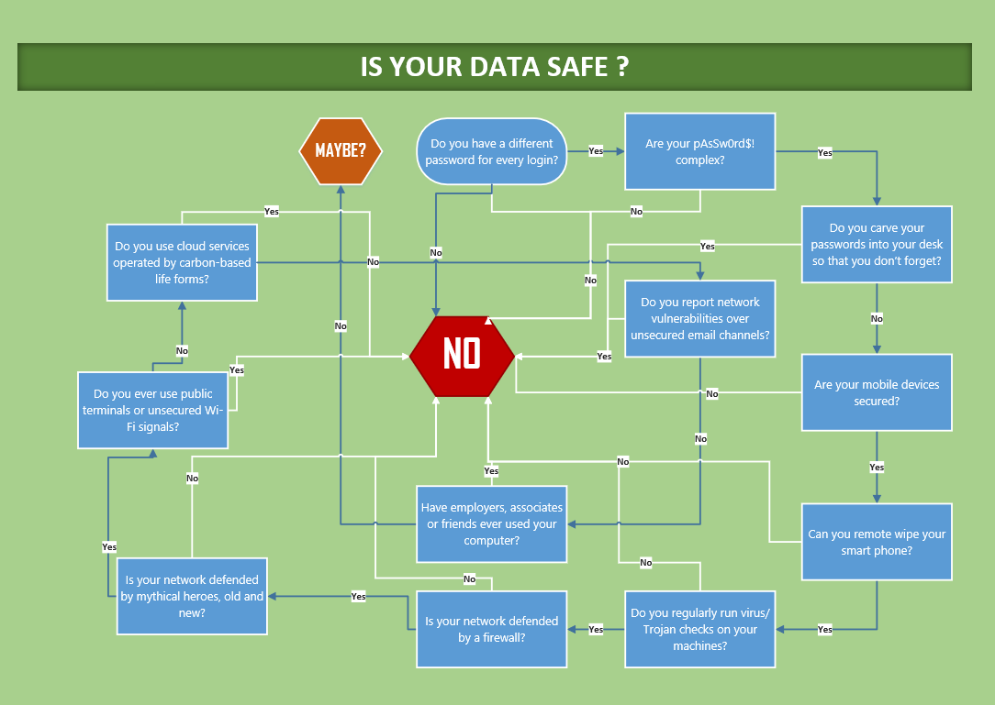

*Figure 5.2.2.1 Entity Relation Diagram: Safety check*

DISCLAIMER: We are not response for any miscommunication students send to each other. It is each student's responsibility to make sure that the book they order is the book they need. We do not guarantees that you may be able to return a book, that is up the the buyer.

## **Security Requirements**

We must have a secure server and website.

We are required to add SQL injection protection.

We must not anyone’s personal identifiable information(PII) except for their school email address for logging in and checking to see if they are using a student account.

## **Software Quality Attributes**

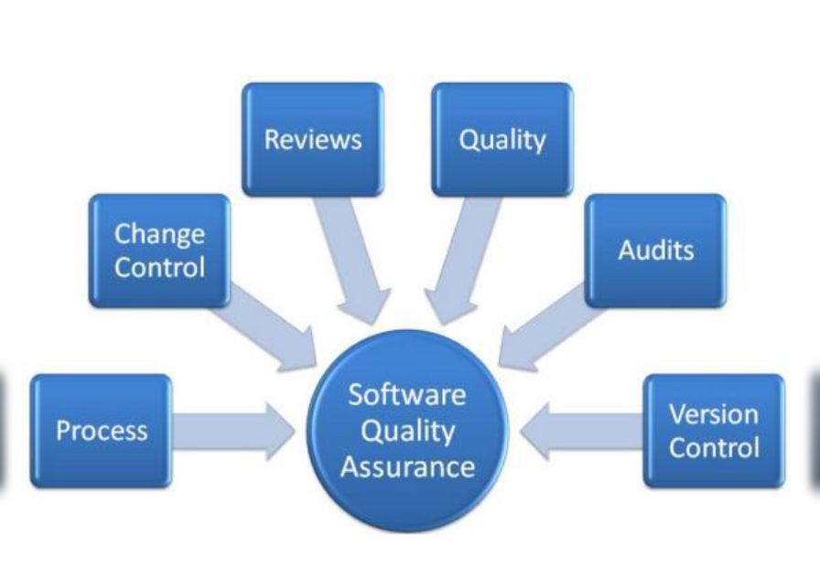

*Figure 5.4.1 Image:Software quality attributes*

## **Business Rules**

We will compile with Kent State Business rules which can be seen on this website

[*https://www.kent.edu/bas/forms-guidelines-policies-and-procedures*](https://www.kent.edu/bas/forms-guidelines-policies-and-procedures)

# **Other Requirements**

**Appendix A: Glossary**

*<Define all the terms necessary to properly interpret the SRS, including acronyms and abbreviations. You may wish to build a separate glossary that spans multiple projects or the entire organization, and just include terms specific to a single project in each SRS.>*

**Appendix B: Analysis Models**

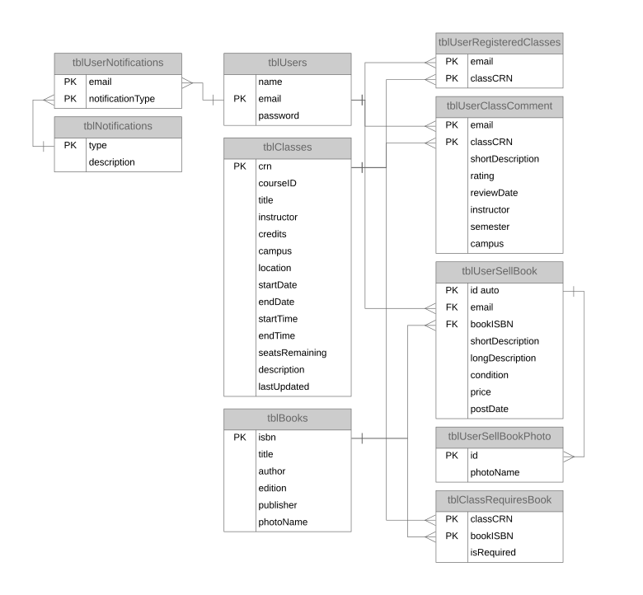

*Figure B.1 Entity Relation Diagram: The Database Management System*

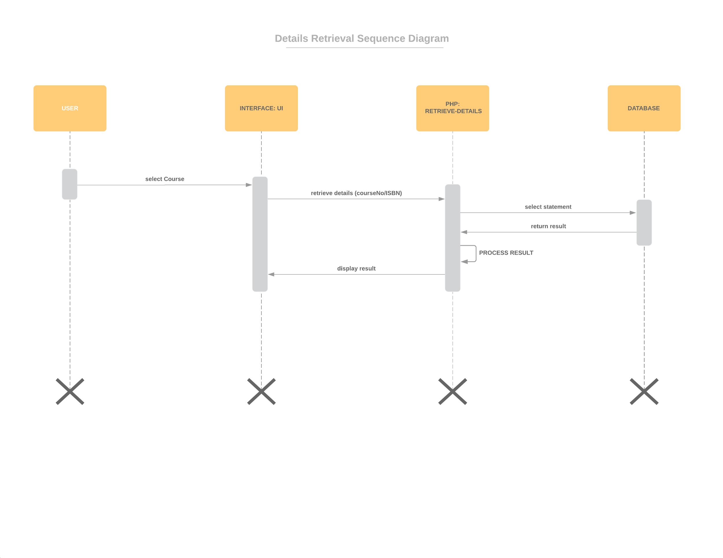

*Figure B.2 - Sequence Diagram: Course/Book Details Retrieval*

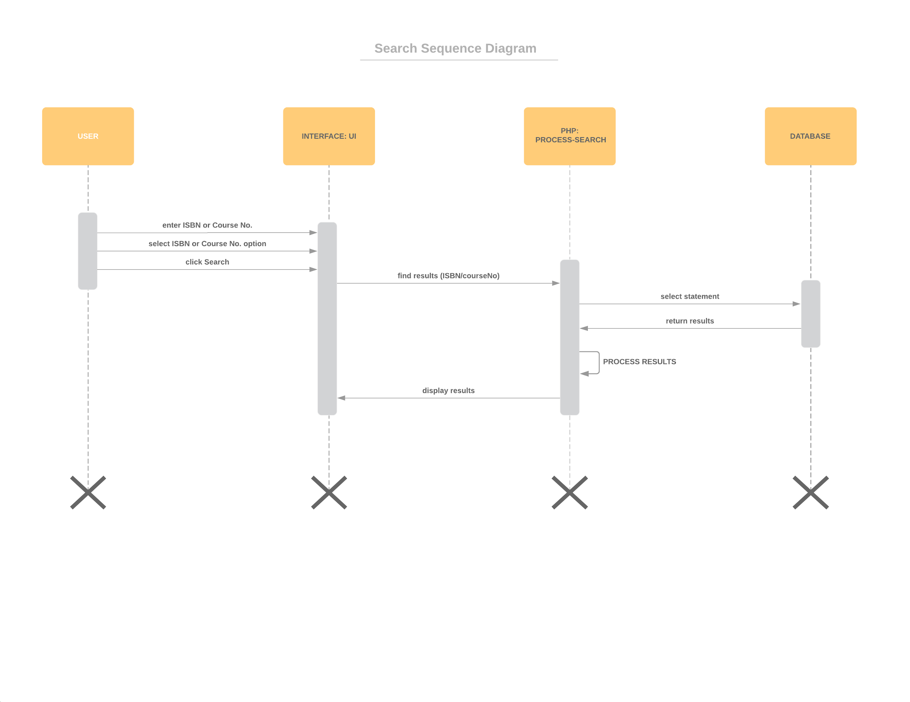

*Figure B.3 - Sequence Diagram: Search*

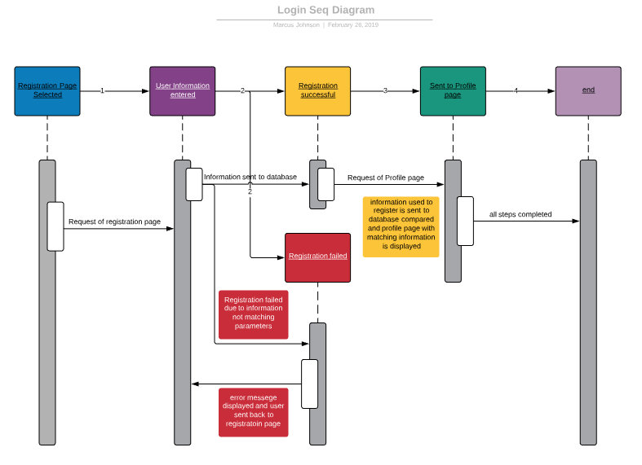

*Figure B.4 Sequence Diagram: Registration page*

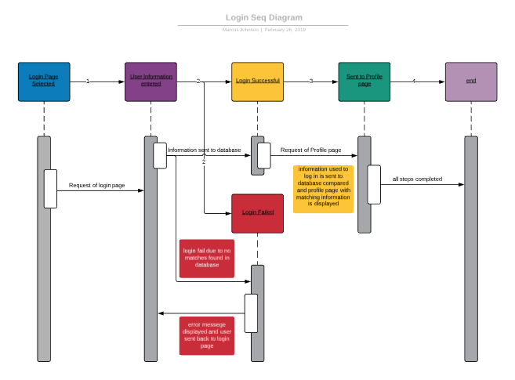

*Figure B.5 Sequence Diagram: Login page*

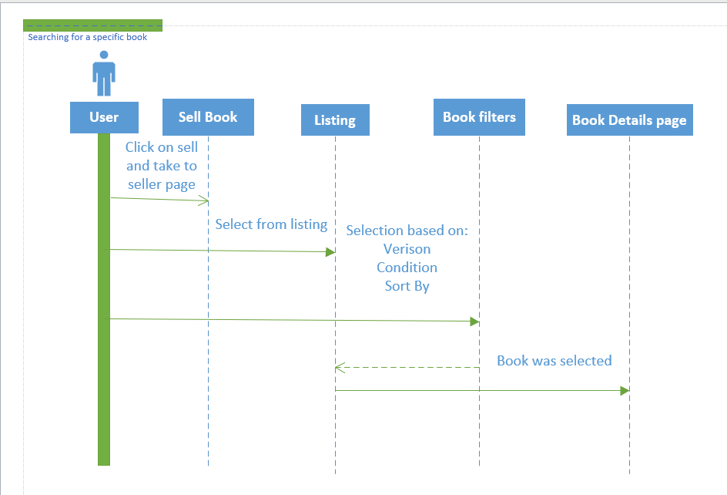

*Figure B.6 Sequence Diagram: Book listing*

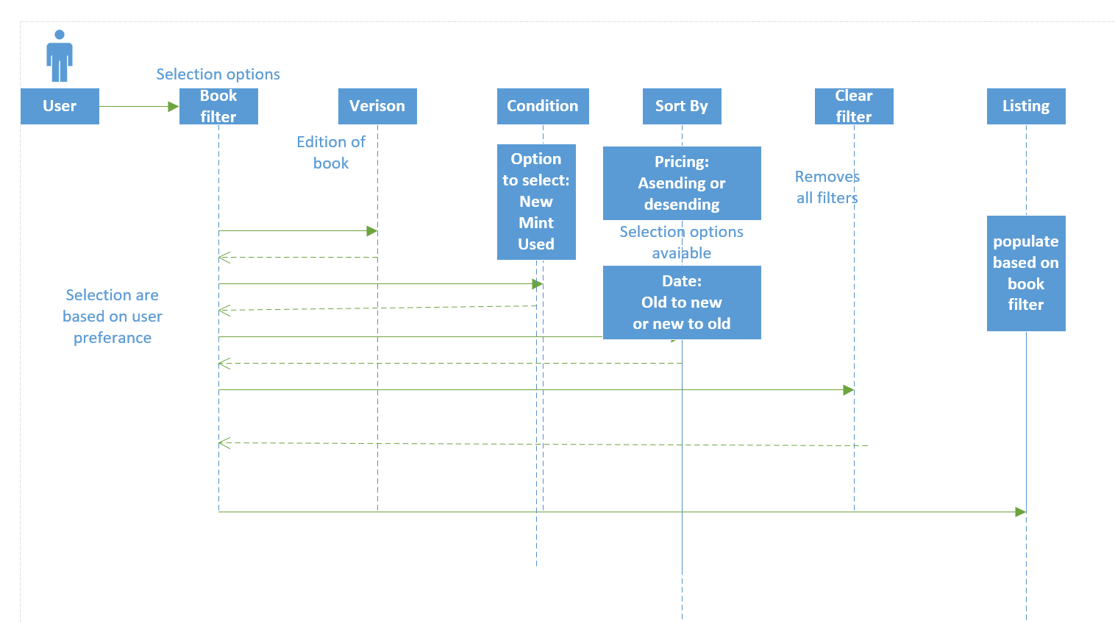

*Figure B.7 Sequence Diagram: Book filter*

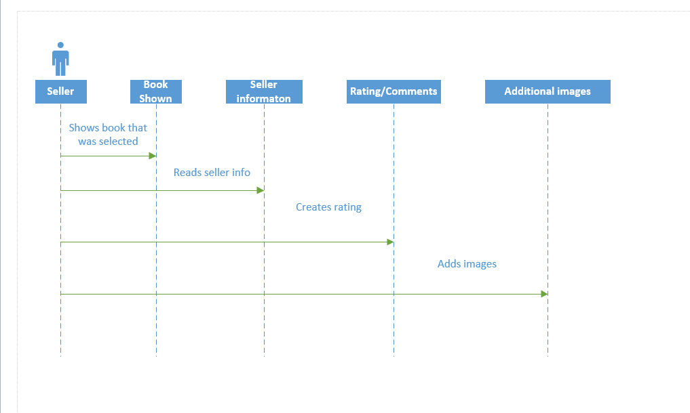

*Figure B.4 Sequence Diagram: Book details (seller)*